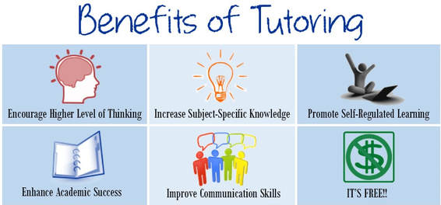

?

32º

y

13

$$d= \sqrt{{(x_{1}-x_{2})}^{2}+{(y_{1}-y_{2})}^{2} }$$

**Math Students**

**Need extra help with math?**

?

$$y=mx+b$$

?

$$\sin^{2}x+ \cos^{2}x=1$$

$$5^{x}=16$$

**Math tutoring** is available every **Wednesday** in Room S8 from **2:50** p.m. to **4:20** p.m.Tutoring will be provided by *students* under the supervision of two math teachers. If you are interested in becoming a math tutor, please see your current math teacher for his/her recommendation.

**Geometry students** that are interested in reviewing for the Keystone test prior to retaking the exam Dec 9 and 10th are welcome to join our afterschool Keystone Program.  The program is offered every Tuesday and Thursday until 4:15. Students will be able to take the 4:30 bus home or can be picked up.  Each session algebra teachers, Mrs. Osczepinski, Ms. Morelli, Ms. Ripa and Mrs. French will review a specific topic of the Keystone exam, provide practice and re-teaching if necessary. Please get in touch with Laurie Osczepinski if you have any questions.  ([osczepinskil@dvsd.org](mailto:osczepinskil@dvsd.org))

**Math Lab (Room A3)**

The Math Lab is open to students from periods 1 – 7 during the school day. Students may come to the lab during their math class, with the permission of their teacher. Students can also come to the Math Lab during their lunch. The Math Lab is equipped with teachers from the DVHS. It is also a place to ask for help with Keystone and SAT review.

**Morning Tutoring (Room A10)**

Morning tutoring from 7:10 am to 8:00 am is offered in room A10 by Mr. Llewellyn. Students from any math class are invited to attend.

**Science Students**

**Need extra help with Science?**

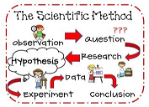

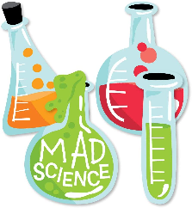

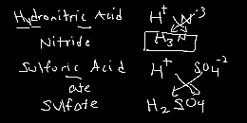

**The Science Lab is an option for any student looking for additional support in their science classes.** The lab can be used by students who are home on quarantine or those returning from an extended absence. The lab is also available to students who desire the opportunity to review and practice science content with enthusiastic educators with excellent breadth of content/curriculum expertise.

The science lab is available to students demonstrating a sincere intent on dedicating this time to supporting their education. There are a variety of ways to begin using the Science Lab:

* Ask your science teacher for details
* Stop by/email Mr. Rupp or Mr. Rhule to begin communication
* Simply show up during 5th period!

For **Science Keystone Retesting studen**ts, we will offer:

* + - * A Schoology class with review documents and self-assessments.
      * A Science Lab with a biology-content expert open daily during all lunches
      * Possible after-school review sessions: more information will be available from your current science teacher soon!

The Writing Lab

The Writing Lab can be remediation, extra help, or extra time for anything.  Students can come to C8 – 1st period and 3rd period to 7th period - or A17 – 2nd period. Any subject can utilize the writing lab. It is writing help, not subject specific.

**After school library** will begin on October 4th. After school library passes are required to attend. Late bus passes will be given out to students who need one. As a reminder, After School Library will be held Monday through Thursday from 2:38 to 4:30.